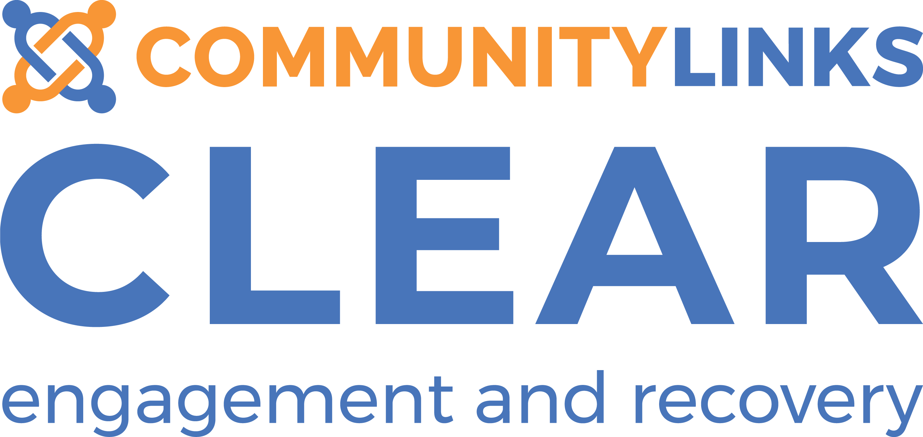

Clear Referral Form

Thank you for your interest in our service. Once the referral has been received, you can expect to hear confirmation from us within three working days.

Please check that all sections of the form are fully completed before sending to avoid delays in the processing of the referral.

Referral type: (Please tick) Anger Course ☐ Mental Health/ Groups ☐

- If you are applying for Anger Course only, following the referral being received we will invite you to an Anger Assessment within ten working days.
- If you are applying to access all Groups/ Mental Health & Wellbeing support, we will invite you to a Welcome Session to inform you about the wider service within ten working days. This will be followed by an invite to an Initial Assessment appointment before accessing the service.
- If you require more information around which referral type best suits your needs, please contact us to discuss.

Referral Criteria:

To be eligible for wellbeing support from Clear you must be:

- Aged 18+
- Living in Kirklees
- Registered with a GP

We accept self-referrals and referrals via professionals and other agencies.

If you require any support in completing the form or require more information, please do reach out and contact us.

Contact Details:

Address:
Community Links Engagement & Recovery (CLEAR)
32 - 34 Lion Chambers
John William Street
Huddersfield
HD1 1ES

Tel: 01484 519 097

Email: clear.huddersfield@commlinks.co.uk

Website: http://www.commlinks.co.uk/clear



(Admin use only) Date referral received:
CLIENT DETAILS:

Name: | D.O.B:
Address:

Postcode:

Tel: | Mobile:
Email:
Emergency Contact: (Name / Relationship / Tel. No.)

GP: (Name /Surgery / Tel. No.)

If this is a self-referral, where did you hear about us?

Are you happy if we contact you via the following methods? (Please tick all that apply):

Telephone ☐
Text ☐
Letter ☐
Email ☐
Other (Please state)

Have you received a mental health diagnosis? (Please tick) Yes ☐ No ☐
If yes, please state diagnosis here:

Do you have any additional support needs that we need to be aware of before you attend Clear?
(e.g. sensory impairment, literacy, dyslexia, neurodiversity, physical health, cultural or faith requirements etc.)

Do you require an interpreter? (Please tick) Yes ☐ No ☐
If yes, please state which language:

Do you regularly use non-prescribed drugs or alcohol? (Please tick) Yes ☐ No ☐
If yes, do you currently receive support around this?

Do you have a diagnosis of dementia? (Please tick) Yes ☐ No ☐
If yes, please give details:

Do you experience any learning difficulties? (Please tick) Yes ☐ No ☐
If yes, please give details:

Are you on Care Programme Approach (CPA)? (Please tick) Yes ☐ No ☐

RISK INFORMATION

For self-referrals, or anyone without a formal risk assessment, is there any relevant information that you think we need to be aware of prior to your assessment?
(E.g. Thoughts of or attempting suicide, self-harm, self-neglect, risk from/to other people, accidental or deliberate incidents, physical or verbal abuse/aggression, criminal history etc…)
If there is ‘no known risk’ – Please just state this instead.

REFERRER DETAILS
(Do not complete this section for self-referrals)

Name: | Role:
Relationship to Client:

Service/ Team Address:

Postcode:

Telephone:  Mobile: | Email:
Please ensure that the client has been informed and agreed to the referral being placed:

(Please confirm) Client aware ☐

Have you attached an up to date risk assessment? (Please tick) Yes ☐ No ☐

Please note: we are unable to process the referral without this information.

If there is ‘no known risk’ - please just state this instead:

DIVERSITY AND MONITORING
(If you do not wish to disclose, please tick ‘prefer not to say’)

Ethnicity
White-British ☐ |  | Black-Caribbean☐ |  |  | Asian-Indian ☐ | White & Black-Caribbean ☐ | Chinese ☐
White-Irish ☐ |  | Black-African ☐ |  |  | Asian-Pakistani ☐ | White & Black-African ☐ | Gypsy/Traveller ☐
White-Other ☐ |  | Black-British☐ |  |  | Asian-Bangladeshi ☐ | White & Asian ☐ | Any other ☐
Prefer not to say ☐ |  | Black-Other☐ |  |  | Asian-Other☐ | Dual Background Other ☐ | Not Known ☐
Gender
Male ☐ |  | Female ☐ |  |  | Non-Binary ☐ | Was this the gender you were assigned at birth? Yes ☐ No ☐ Prefer not to say ☐
Sexuality
Heterosexual ☐ |  | Gay ☐ |  | Lesbian☐ | Bisexual ☐ | Other ☐ | Prefer not to say ☐
Relationship Status
Single ☐ | Married ☐ |  | Civil Partnership ☐ |  | Co-Habiting ☐ | Other ☐ | Prefer not to say ☐
Dependent Children
Yes ☐ |  | No ☐ |  |  | Prefer not to say ☐
Disability
Yes ☐ |  | No ☐ |  |  | Prefer not to say ☐
Religion
Christian ☐ |  | Muslim ☐ |  |  | Jewish ☐ | Sikh ☐ | Hindu ☐
Buddhist ☐ |  | Other ☐ |  |  | None ☐ | Prefer not to say☐
Residency Status
British Citizen ☐ |  | EU National ☐ |  |  | Foreign Student☐ | Destitute ☐ | Asylum Seeker ☐
Refugee ☐ |  | Other ☐ |  |  | Prefer not to say☐
Language
Is English your First Language? (Please tick) Yes ☐ No ☐

If no, please state your first language here:

We will hold electronic information about you so that we can provide you with the best level of support whilst you are accessing the Clear service. This information will be held in strict accordance with the Data Protection Act 1998. We will only use your information for the purposes that we have told you about and for operational reasons when we are required to do so by Law (e.g. information we are required to provide during an audit). We will also comply with any legal request by a court or authorised body that requires us to release information to them.

Your information will remain confidential but we may share your information on a ‘need to know’ basis with other agencies or services involved in your support to ensure consistency in the care you receive. This also enables us to manage any risk issues or safeguarding concerns safely.

“I consent to Community Links Engagement and Recovery (CLEAR) using and sharing my information in line with the Data Protection Act 1998 and within the provisions outlined above.”

Client Signature: ___________________________________

Date: ___________________________________________

INFORMATION SHARING AND CONSENT

