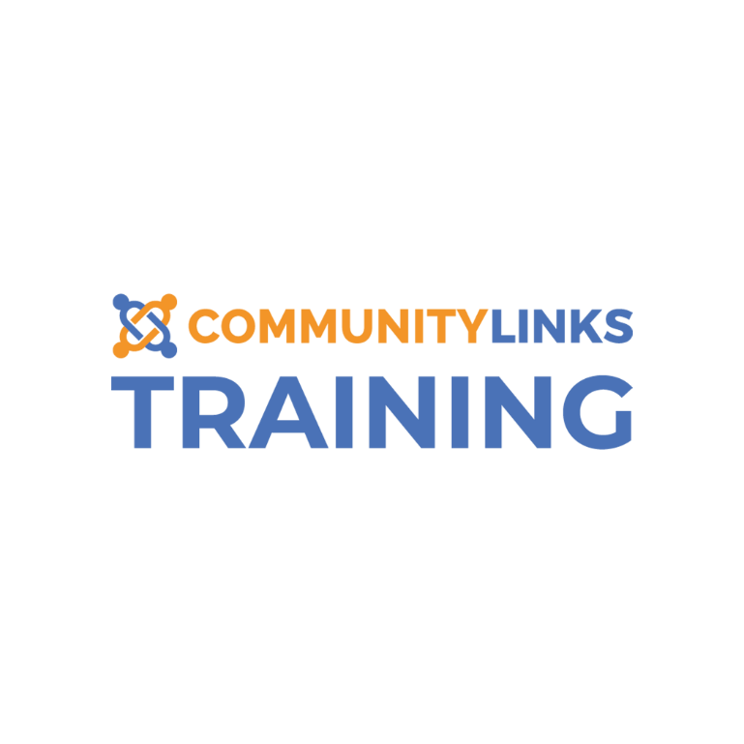

**FAQ’s**

**Being You Leeds funded courses delivered by Community Links Training- *(a Service of Inspire North)***

**Am I the right person for this training?**

To book on to this training you need to be in a ‘direct supporting role’. This means that most of your work is done supporting people face-to-face (and perhaps also over the phone or online).

You need to be doing this for a third-sector organisation or group (more on this below).

You can be a volunteer or a paid worker.

**Do I work or volunteer for a third-sector organisation?**

The third-sector includes, charities, community groups, cooperatives, non-profit organisations, social enterprises etc. It is anything that isn’t a business out to make profit and is not a government department.

Schools, universities, NHS and Local Authorities are NOT considered to be third sector organisations.

**What do we mean by deprived areas?**

There are lots of amazing things that happen in ‘deprived’ areas, and a wide variety of interesting, capable, creative and hard-working people live in them.

However deprived areas lack some of the essential things that can help people have happy and healthy lives, like decent housing, well-paying jobs and local services. This leads to people suffering health inequalities (more on this below).

This is why we want to make sure that organisations which work in the 10% most deprived areas get priority when it comes to free training. If you aren’t sure, you can find the information at [IMD 2019 Leeds map](https://leedscc.maps.arcgis.com/apps/View/index.html?appid=c7654fdc77044d8cb6019a947506f3fa) – the darkest shaded areas are the most deprived.

**What are health inequalities?**

Health inequalities are avoidable and unfair differences in health between different groups of people. Some groups of people die younger, are more likely to die by suicide, have more long-term health conditions, experience more difficulty accessing services and treatments and experience discrimination.

Leeds has identified certain groups as experiencing the highest barriers to good health and wellbeing. If you work in the third sector supporting any of the following people, you are eligible for this free training:

Care leavers, Gypsy and Traveller people, Homeless people, LGBTQ+ people, Older people, People from Black Asian and Minority Communities including Roma people, People leaving prison, People living in poverty, People who are digitally excluded, People who experience domestic violence, People who misuse drugs or alcohol, People with autism or a learning disability, People with a physical or sensory impairment, long term conditions or mobility issues, People with mental health issues, Sex Workers, Refugees, Asylum Seekers and Migrant Communities.

**What if I need to cancel?**

It is important that you only book on this free training if you know you will be able to attend. If your plans change and you need to cancel, please do so with at least two-weeks notice so that we can offer your place to someone else. If you fall ill, or there is an emergency, closer to the day of the training course and you will not be able to make it, please let us know as soon as you can.

Late cancellation for non-urgent reasons may prevent you from being considered for future free training, except where there is low take-up of spaces. Repeated cancellation will occur a set administration fee of £50.

**Can someone help me complete the form?**

If you would like support with completing the booking form, please contact Community Links Training by email [training@commlinks.co.uk](mailto:training@commlinks.co.uk) or call [0113 273 9660](tel:0113%20273%209660)

**How will I know if I have a place on this training?**

You will be notified 4 weeks in advance if you have been allocated a place on a course. If the course is due to start in less than 4 weeks from the time you registered, please contact Community Links Training by email [training@commlinks.co.uk](mailto:training@commlinks.co.uk) or call [0113 273 9660](tel:0113%20273%209660)

**What if I’m not eligible for this free training?**

If you feel this training would be valuable to you or your colleagues, and you have access to a training budget, you can book on to another Community Links course which is not being funded by Being You Leeds. Prices are advertised on their website. If you do not have a training budget, you may be eligible for other free training. For information about other free training courses and online suicide prevention resources, please visit:

[West Yorkshire Suicide Prevention Training (suicidepreventionwestyorkshire.co.uk)](https://suicidepreventionwestyorkshire.co.uk/suicide-prevention-training) <https://suicidepreventionwestyorkshire.co.uk/suicide-prevention-training>