

|  |  |  |  |
| --- | --- | --- | --- |
| **Monday** | Meditation Mondays | 11am – 1pm |  |
| **Tuesday** | Creative Writing  Music Group (Fortnightly)  *(5th & 19th October)* | 2pm – 4pm  5:30pm-7:30pm |  |
| **Wednesday** | Men’s Group  (*except 6th & 13th October- office closed)* | 5:30pm-7:30pm | Square |
| **Thursday** | Safe Space  *Phone: 7th,21st Oct /Office: 14th, 28th Oct* | 11am – 1pm | Square |
| **Friday** | Acupuncture  Hearing Voices Peer Support | 10:30am-11:45am  1pm-2:30pm |  |

**CLEAR Dewsbury Timetable**

***(Starting from the Mon 4th October)***

**October**



|  |  |  |  |
| --- | --- | --- | --- |
|  |  |  |  |
| Extras |  |  |  |
| **Wed 6th October** | Lantern Parade at Crow’s Nest Park, Dewsbury | 5:30pm-7:30pm | Square |
| **Mon 25th October** | Emotional Freedom Technique Group | 4:30pm-6:00pm | Square |
|  |  |  |  |





|  |  |  |  |
| --- | --- | --- | --- |
| **Monday** | Meditation Mondays | 11am – 1pm |  |
| **Tuesday** | Creative Writing  Music Group (fortnightly)  (Nov 2nd, 16th & 30th) | 2pm -4pm  5:30pm-7:30pm | Square  Square |
| **Wednesday** | Men’s Group | 5:30pm-7:30pm | Square |
| **Thursday** | Safe Space  (Phone: 4th & 18th Nov  Office: 11 & 25th Nov) | 11am – 1pm | Square |
| **Friday** | Acupuncture  Hearing Voices Peer Support | 10:30am-11:45am  1pm – 2.30pm | Square |



|  |  |  |  |
| --- | --- | --- | --- |
| **Thurs 4th Nov** | History Mystery | 5pm-7pm | Square |
| **Tues 9th Nov** | Games Evening | 5:30pm-7:30pm | Square |
| **Wed 17th Nov** | Animal Therapy Visit  *(Huddersfield Office Only, see poster)* | 11am-12:30pm | Square |
| **Mon 8th & 22nd Nov** | Emotional Freedom Techniques Group | 4:30pm-6:00pm | Square |



**November 2021**



|  |  |  |  |
| --- | --- | --- | --- |
| **Wed 8th Dec** | Wellbeing Skills Social | 10am-12pm | Square |
| **Thurs 10th Dec** | Inflate a Nation  (In Huddersfield -Sign up only, see poster) | 6pm-7pm | Square |
| **Mon 13th Dec** | Emotional Freedom Technique Group | 4:30pm-6:00pm | Square |
|  |  |  |  |
|  |  |  |  |

**December 2021**

***(Runs until 3pm 24th December)***



|  |  |  |  |
| --- | --- | --- | --- |
| **Monday** | Meditation Monday | 11am – 1pm |  |
| **Tuesday** | Creative Writing  Music Group (Fortnightly)  (14th December only) | 2pm-4pm  5:30pm-7:30pm | Square  Square |
| **Wednesday** | Men’s Group  (except 15th & 29th – office closed) | 5:30pm-7:30pm | Square |
| **Thursday** | Safe Space  (Phone: 2nd & 16th Dec  Office: 9th & 23rd Dec) | 11am- 1pm | Square |
| **Friday** | Acupuncture  Hearing Voices Peer Support | 10:30am-11:45am  1pm – 2.30pm | Square  Square |

**EXTRAS**



Creative Weekends

Come join us for our Creative Weekends including Board Games, Movies and Arts and Crafts.

**Drop-in times:**

**SATURDAYS** @ Huddersfield office – **11am till 1pm** and **2pm till 4pm**

**SUNDAYS** @ Dewsbury Office -**11am till 1pm** and

**1.30pm – 3.30pm**



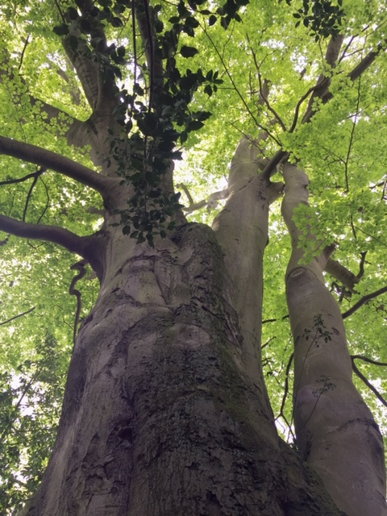



|  |  |  |  |  |  |  |
| --- | --- | --- | --- | --- | --- | --- |
| **Social Media**  **Follow us on:**  Instagram: @Clear_Kirklees  Twitter:  CL Kirklees  www.facebook.com/CommunityLinks |  |  |  | **Participation**  **Day – 7 October**  **At Huddersfield**  11:30-1pm  A chance for you to express your ideas for new groups/ existing groups/ or the service. |  |  |
|  |  |  |  |  |  |  |
|  |  | **Auricular Acupuncture**  Try out our new Dewsbury Group. Speak to a staff member for further info. |  |  |  | **Music Group**  Tinkle a triangle, guide those guitar fingers or compose on keyboard! -speak to Jon. |
|  |  |  |  |  |  |  |
|  |  |  |  | **Ask about our Courses in Anxiety, Confidence, Sleep & Mindfulness**  (speak to your Key Worker) |  |  |
|  |  |  |  |  |  |  |





**Clear Huddersfield**

32-34 Lion Chambers, John William Street, Huddersfield, HD1 1ES

01484 519 097

[clear.huddersfield@commlinks.co.uk](mailto:clear.huddersfield@commlinks.co.uk)

**Clear Dewsbury**

26 Bond Street, Dewsbury, WF13 1AU

01924 465 054

[clear.dewsbury@commlinks.co.uk](mailto:clear.dewsbury@commlinks.co.uk)

