

**CLEAR Huddersfield Timetable**

**July 2022**

***(starting from Monday 4th July)***

|  |  |  |  |
| --- | --- | --- | --- |
| **EXTRAS** |  |  |  |
| **Thurs 14th July**  **Fri 15th July**  **Tues 19nd July**    **Fri 22nd July**  **Mon 25th July**  **Thurs 28th July** | Animal Therapy  *(Sign up through keyworker)*  Barge Trip  *(Sign up through keyworker)*    BAME Peer Support Group    Yoga  *(Sign up through keyworker)*  Attic Stories/ Open Mic Night  *(Sign up through keyworker)*    ‘World of Tech’! | 11-12:30pm  9-4:00pm  3-3:30pm  11-12pm  7:30pm- 9:30pm  3.15-4:15pm |  |
|  |  |  |  |
|  |  |  |  |
|  |  |  |  |

|  |  |  |  |  |
| --- | --- | --- | --- | --- |
| **Monday** | Men’s Group  Hearing Voices Peer Support Group | 2.30pm-4:30pm  5.30pm – 7.00pm |  |  |
| **Tuesday** | Tranquil Tuesdays  *(sign up through worker)*  Time Travel Tuesdays | 1pm-2:30pm  5:30- 7.00pm |  |  |
| **Wednesday** | Allotment HD2 2QU  Creative Writing | 10am-12pm  5:30pm-7:00pm | Square  Square |  |
| **Thursday** | Energy Therapy    Give…a few Words  *(every 2 wks – 7th & 21st)* | 2pm-3:30pm  3:30-4:30pm | Square    Square |  |
| **Friday** | All Together  *(Sign up through Keyworker)* | 1pm – 3pm |  |  |



|  |  |  |  |
| --- | --- | --- | --- |
| **Monday**  **(Closed on 29th August )** | Men’s Group  Hearing Voices Peer Support Group | 2:30pm-4:30pm  5.30pm– 7.00pm | Square |
| **Tuesday** | Tranquil Tuesdays  *(sign up through keyworker)*  Time Travel Tuesdays | 1pm-2:30pm  5:30-7:00pm | Square  Square |
| **Wednesday** | Allotment (HD2 2QU)  Creative Writing | 10am-12pm    5:30-7:00pm | Square    Square |
| **Thursday** | Energy Therapy  Give…a few Words  *(every 2 wks – 4th & 18th )* | 2-3:30pm  2pm-3:30pm | Square  Square |
| **Friday** | All Together  (*Sign up through Key Worker*) | 1-3pm | Square |

**August 2022**

**EXTRAS See posters for further details**



|  |  |  |  |
| --- | --- | --- | --- |
| **Thurs 4th August**  **Thurs 11th August** | CLEAR Quiz Night  Drumming Workshop | 5:30-7:30pm  11-12:30pm |  |
| **Fri 12th August**  **Tues 16th August**  **Thurs 18th August**  **Thurs 25th August** | Yoga  BAME Peer Support Group  Summer Bash  Beaumont Park Walk | 11-12:00pm  3-4:30pm  3:30-6:30pm  2:30-4:30pm |  |
|  |  |  |  |
|  |  |  |  |

|  |  |  |  |
| --- | --- | --- | --- |
| **Monday** | Men’s Group  Hearing Voices Peer Support Group | 2:30-4:30pm  5.30pm – 7.00pm | Square  Square |
| **Tuesday** | Tranquil Tuesdays  *(sign up through keyworker)*  Time Travel Tuesdays | 1pm-2:30pm  5:30-7:00pm | Square  Square |
| **Wednesday** | Allotment HD2 2QU  Creative Writing | 10am-12pm  5:30pm-7:00pm | Square  Square |
| **Thursday** | Energy Therapy  Give…a few Words  *(every 2 wks – 1st, 15th & 29th)* | 2pm-3pm  2pm-3:30pm | Square  Square |
| **Friday** | All Together  *(Sign up through Keyworker)* | 1pm – 3pm | Square |



**September 2022**





|  |  |  |  |
| --- | --- | --- | --- |
| **Extras** |  |  |  |
| **Fri 2nd Sept** | Yoga | 11-12:00pm |  |
| **Tues 20th Sept** | BAME Peer Support Group | 2-3:30pm |  |
| **Thurs 29th Sept** | Greenhead Park Walk  (World Heart Day – see poster) | 1:30-3pm |  |
|  |  |  |  |

Come join us for our Creative Weekends including Board Games, Movies and Arts and Crafts.

**Drop-in times:**

**SATURDAYS** @ Huddersfield office – **11am till 1pm** and **2pm till 4pm**

**SUNDAYS** @ Dewsbury Office -**11am till 1pm** and

**1.30pm – 3.30pm**

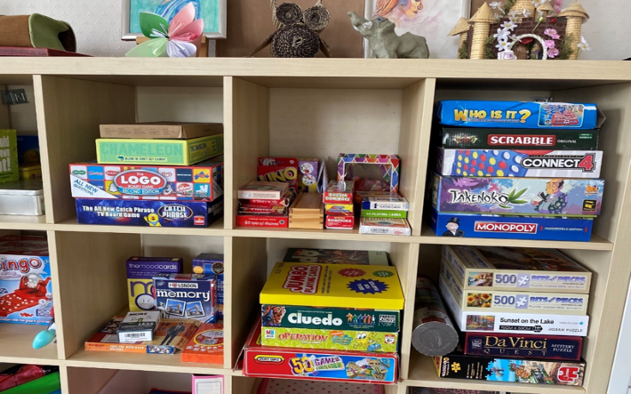

Creative Weekends



Come join us for our Creative Weekends including Board Games, Movies and Arts and Crafts.

**Drop-in times:**

**SATURDAYS** @ Huddersfield office – **11am till 1pm** and **2pm till 4pm**

**SUNDAYS** @ Dewsbury Office -**11am till 1pm** and

**1.30 – 3.30pm**

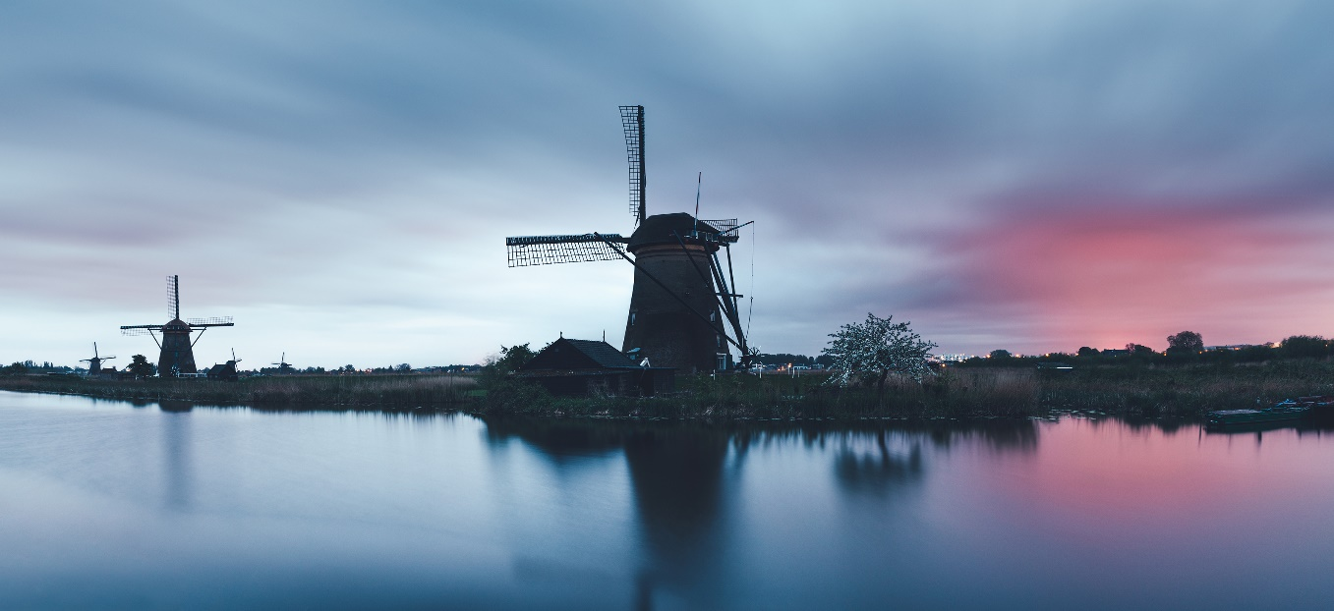



|  |  |  |  |  |  |  |
| --- | --- | --- | --- | --- | --- | --- |
| **Social Media**  **Follow us on:**  Instagram: @Clear_Kirklees  Twitter:  CL Kirklees  www.facebook.com/  CommunityLinks |  |  |  | **Huddersfield Pride**  **9th July**  Celebrate and see a  Variety of stalls and activities on Kings Street. |  |  |
|  |  |  |  |  |  |  |
|  |  | **Drumming Workshop**  **11th August**  Tap your fingers,  Tap your feet.  Ease your mind  With this alternative beat! |  |  |  | **Yoga – see ‘Extras’ each month**  Learn to bend in the breeze/ Chanel your inner Lotus! |
|  |  |  |  |  |  |  |
|  |  | **CLEAR QUIZ NIGHT**  **4th August**  Back by popular demand! |  | Young woman in nature |  |  |
|  |  |  |  |  |  |  |

**BARGE TRIP**

15th July

Meandering in the midday sun on the quiet canals of England. (See poster)





**Clear Huddersfield**

32-34 Lion Chambers, John William Street, Huddersfield, HD1 1ES

01484 519 097

[clear.huddersfield@commlinks.co.uk](mailto:clear.huddersfield@commlinks.co.uk)

**Clear Dewsbury**

26 Bond Street, Dewsbury, WF13 1AU

01924 465 054

[clear.dewsbury@commlinks.co.uk](mailto:clear.dewsbury@commlinks.co.uk)



**Energy Therapy**

Holistic therapies to enhance physical and emotional healing. Speak to worker for more information.